L 12 : probabilities (Part III)

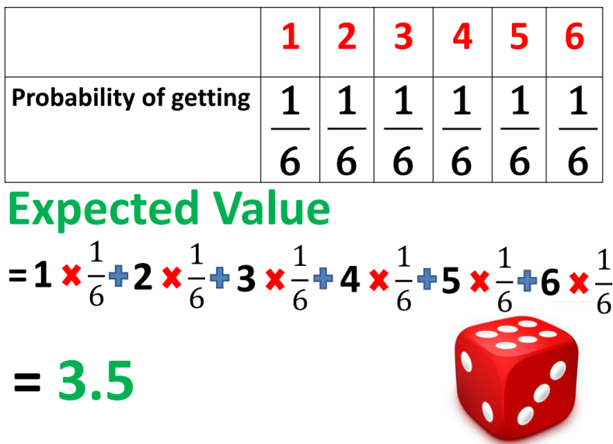
Expected Value

Let’s get started!

1. Probability of getting a $10 note = $\frac{1}{4}$ Find the expected value.
Probability of getting a $20 note = $\frac{1}{4}$
Probability of getting a $50 note = $\frac{1}{2}$

3. P (50 marks) = 80%
P (100 marks) = 15%
P (800 marks) = 5%
Find the expected mark.
2. P (10 marks) = 20%
P (20 marks) = 35%
P (30 marks) = 45%
Find the expected mark.

4. Macy takes part in a drawing competition. It is known that $\$ 3 000$, $\$ 1 000$ and $\$ 500$ will be awarded for the champion, 1st runner-up and 2nd runner-up respectively. If the probabilities that Macy becomes the champion, 1st runner-up and 2nd runner-up are $0.1$, $0.2$ and $0.3$ respectively, find the expected value of her award.

5. A wallet contains two $\$ 10$ notes, five $\$ 20$ notes and three $\$ 100$ notes. If a note is drawn from the wallet randomly, what is the expected value of the note drawn?
(a) Find the probabilities of drawing a $\$10$ note.
(b) Fin the expected value of the draw.

6. In a game, a player has to draw a marble randomly from a bag which contains $1$ blue marble,
$1$ red marble and $1$ green marble. The points the player can get are shown below:
Marble | Blue | Red | Green
Points | $12$ | $-18$ | $9$
Find the expected value of the points got by the player.

7. In a game, a player has to draw a card from $52$ playing cards.
Card | A | 2 | 3 | 4 | 5 | 6 | 7 | 8 | 9 | 10 | J/Q/K
Points | +11 | +5 | +5 | +5 | +5 | -5 | -5 | -5 | -5 | 10 | 10
Find the expected value of the points got by the player.

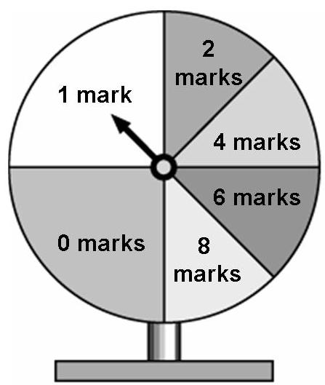
8. The figure shows a lucky wheel. The semi-circle on the left of the wheel is divided into two equal sectors while the semi-circle on the right is divided into four equal sectors. Find the expected value of the marks obtained in spinning the lucky wheel once.

9. Entrance Fee for lucky draw: $200
P ($50) = 70% P ($150) = 20% P ($1000) = 10%
Calculate the expected value and decide whether it is worth to play the lucky draw.

Calculate the expected value:

Compare the values:

Conclusion:

10. Maggie is planning to travel aboard. She had caught a cold and suffered from endemic disease in her previous trips, the medical fee was $\$ 300$ and $\$ 1 000$ respectively. Therefore, she is thinking of buying a travelling insurance of $\$ 200$. It is estimated that the probability of catching a cold and suffering from endemic disease are $0.2$ and $0.1$ respectively. Ignoring other factors, do you think that Maggie should buy the travelling insurance?

11. An organization issues $50 000$ lucky draw tickets. The prizes are as follows:
Prize item | Number of prizes | Prize
1st prize | $$1$$ | $$\$ 100 000$$
2nd prize | $$1$$ | $$\$ 50 000$$
3rd prize | $$3$$ | $$\$ 10 000$$
Consolation prize | $$5$$ | $$\$ 1 000$$

(a) Find the expected value of the prize of each of the lucky draw tickets.
(b) If Jacky buys a lucky draw ticket of $\$ 20$, does he gain or suffer a loss on average? Explain your
answer.

12. In a game, a player draws a ball at random from a box. In the box, there are $50$ balls of the same size and each ball is marked with a distinct number from $1$ to $50$ inclusively. If the ball drawn is marked with one of the following numbers $8, 18, 28, 38$ or $48$, a $\$ 300$ will be awarded.
(a) Find the expected value of the amount of money a player gets in one game.
(b) If a player has to pay $\$ 40$ for playing the game once, is the game favourable to the player?

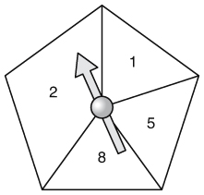
13. The figure shows a lucky wheel in the shape of a regular pentagon. David spins the lucky wheel and gets the points marked on the region where the pointer stops.
(a) Find the probability that David gets
(i) $5$ points, (ii) $2$ points.
(b) Find the expected value of the points David gets in one spin.
(c) David will receive a special prize if he gets $10$ points or more in two spins.
Given that David gets $8$ points in the first spin, find the probability that he
receives the special prize.

14. William plays a game. First he draws a ball from a bag containing three balls labelled $1, 2,$ and $3$. If ball $3$ is drawn in the first part, then he wins $\$ 30$. The ball drawn is put back and one ball is drawn from the bag again. However he will lose $\$ 30$ if the second ball is $3$ too. If the ball drawn (not $3$) is the same as in the first draw, William can still get $\$ 12$; otherwise, he can’t get any money.
(a) Draw a table to list out all the possible outcomes when he draws two balls from the bag with replacement.
(b) Hence, find the expected amount of money William can win from the game.
(c) If it takes William $\$ 10$ to play the game, do you think the game is favourable to him?


If we roll the dice twice, what is the expected sum of values?
Expected Value for the first roll
= 3.5
Expected Value for the second roll
= 3.5
Sum of the expected values
= 3.5 × 2 = 7

Give it a try

You have learnt more! Go on!

15. Gary tosses two coins separately. He will be rewarded $50$ marks if he gets a tail but deducted $20$ marks if he gets a head. Find the expected total mark after the two tosses.

16. There are $10$ cards with number ‘$0$’ to ‘$9$’ respectively. Mary draws a card out of ten for three times separately and she will get the score with the same value as the cards she has got. Find the expected total score.

17. There are $30$ light bulbs in a batch. The probability that a light bulb is faulty is $0.03$. Estimate the number of faulty light bulbs in $5$ batches of light bulbs.

18. The probability that a newly born baby to be heavier than $8$ pounds is $0.15$. Doris has just given birth to $4$ babies, find the expected number of Doris’s babies with weight less than or equal to $8$ pounds.

19. In a multiple-choice test paper, each question has three options $A, B$ and $C$. Only one of the options is correct. Tom does not know how to answer two questions in the test, so he selects the answers randomly.
(a) List all the possible outcomes in a table. (Use T to stand for correct and F stand for wrong.)
Answer of second question
 |  | T | F | F
Answer of  first question | T
 | F
 | F
(b) (i) Find the probability that the two answers chosen are correct.
(ii) Find the probability that only one of the two answers is correct.
(c) $2$ marks will be rewarded for a correct answer while$0$ mark will be given for incorrect answer. Find Tom’s expected total score.

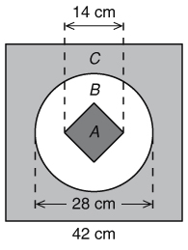
20. The figure shows a square dartboard with a circle and a square drawn inside. It is given that $9$ marks will be awarded for hitting zone $A$, $3$ marks will be awarded for hitting zone $B$ and $2$ marks will be deducted for hitting zone $C$. Tom throws a dart onto the dartboard at random. (Take $π=\frac{22}{7}$.)
(a) Find the probabilities of hitting each zone on the dartboard.
(b) Find the expected value of the marks Tom gets in one throw.

Final Boss!

